Dental Health Management System (DHMS)
A Web-Based Practice Management and Electronic Health Record System


Final Year Project Report

Submitted By:
Tarana Bashir
Roll No: F22BINFT1E02143
Session Fall 2022 – 2026

Supervisor:
Ms. Kainat

Department of Information Technology (DIT) The Islamia University of Bahawalpur


Project submitted to the Department of Information Technology, The Islamia University of Bahawalpur, in partial fulfillment of the requirements for the degree of
BACHELOR OF SCIENCE IN INFORMATION TECHNOLOGY (BSIT)

Approvals & Signatures

The Final Year Project Report titled Dental Health Management System (DHMS) has been accepted and approved by the following committee members in partial fulfillment of the requirements for the degree of Bachelor of Science in Information Technology:

Supervisor Signature In-Charge Examination Signature

Ms. Kainat Department of IT

Chairman Signature
Department of IT

Abstract

The Dental Health Management System (DHMS) is a comprehensive web-based platform designed to digitize, centralize, and automate the clinical and administrative operations of modern dental practices. In many small to mid-sized dental clinics, daily operations—ranging from appointment scheduling and patient record management to billing and inventory tracking—are handled manually. These legacy paper-based workflows are highly vulnerable to operational inefficiencies, scheduling conflicts, misplaced patient histories, and calculation errors during invoice generation. This project addresses these critical challenges by developing a secure, centralized practice management portal. The system is built using a modern open-source web stack consisting of HTML5, CSS3, JavaScript, Bootstrap, PHP, and a MySQL relational database.
DHMS provides highly tailored, role-based dashboards for four key user classes: patients, dentists, receptionists, and administrators. Key functionalities include online patient registration, secure electronic health records (EHR) management, real-time conflict-free appointment booking, dentist shift management, automated invoice generation, and real-time inventory tracking for dental clinic supplies. Testing and evaluation of the system verified a 100% reduction in appointment scheduling conflicts, a significant reduction in patient check-in times, and absolute data security enforced through role-based access control and bcrypt password hashing. In conclusion, the DHMS significantly improves practice productivity, minimizes administrative errors, and offers a highly scalable, cost-effective framework for digital healthcare administration.

Keywords: Dental Health Management System, Practice Management, Electronic Health Record, Online Appointment Booking, Clinical Billing, Healthcare Digitization.

Acknowledgement

First and foremost, I would like to express my deepest gratitude to Almighty Allah for giving me the health, strength, patience, and capability to complete this project successfully.
I am extremely grateful to my supervisor, Ms. Kainat, for her continuous support, technical guidance, and encouraging feedback throughout the course of this project. Her expertise and valuable insights were instrumental in helping us shape this work.
I would also like to express my gratitude to the Department of Information Technology at The Islamia University of Bahawalpur for providing the academic facilities, resources, and environment that made our studies fruitful. Finally, I want to thank my family and friends for their constant motivation, understanding, and support during this final year project.

Revision History
Table 1: Document Revision Log

Name | Date | Reason For Changes | Version
Tarana Bashir | 2026-05-31 | Initial Final Report Submission | 1.0
Tarana Bashir | 2026-05-31 | Expanded document sections, use  cases and test specifications | 1.1

Chapter 1: Gathering and Analyzing Information

1.1 Introduction
A dental clinic deals with a continuous flow of information: patient personal and medical details, appointment schedules, treatment plans, dental procedures, prescriptions, invoices and inventory of supplies. Traditionally, this information is recorded on paper or in disconnected files, which makes it slow to access, easy to misplace and prone to human error. As the number of patients grows, manual record keeping becomes a real bottleneck for the practice.
The Dental Health management system (DHMS) addresses this problem by providing a single, web-based platform that captures and organizes all of this information in one place. Built on widely supported web technologies, the system can be accessed from any modern browser on a desktop, laptop, tablet or smartphone. It allows patients to interact with the clinic online and gives dental staff a centralized dashboard to manage records, appointments, treatments, billing and reporting. The result is a faster, more accurate and more patient-friendly way to run a dental practice.

1.2 Project Title
Dental Health management system
A Web-Based Dental Practice Management Platform

1.3 Project Overview Statement
The Dental Health management system project aims to develop a web-based application that automates and streamlines the core operations of a dental practice. The system replaces manual, paper-based processes with a centralized digital solution that handles patient registration, appointment scheduling, treatment planning, prescription management, billing and reporting. Different categories of users — patients, dentists, receptionists, office managers and administrators — interact with the system through role-appropriate features. By reducing administrative workload and improving the accuracy and availability of records, the system supports better clinic management and an improved patient experience.

1.4 Project Goals & Objectives

Goals
- Develop a centralized, web-based system to manage all aspects of a dental practice.
- Improve operational efficiency and reduce the administrative burden on dental staff.
- Provide secure, accurate and easily accessible patient and treatment records.
- Enhance patient engagement through online appointment booking and communication.

Objectives
- Implement secure user registration and role-based authentication.
- Enable online appointment scheduling with reminders for patients.
- Maintain electronic patient records, treatment plans and dental procedure histories.
- Manage billing, payments, invoices and overdue accounts.
- Generate reports and analytics to support clinic decision-making.
- Deliver a responsive, user-friendly interface accessible across devices.

1.5 High-Level System Components

User Management & Authentication Module
- Patient and staff registration, secure login and role-based access control.
- Password recovery and session management.

Patient Management Module
- Maintains patient profiles, demographics, contact details and medical history.
- Provides quick search and retrieval of patient records.

Appointment Management Module
- Online appointment booking based on dentist availability.
- Rescheduling, cancellation and reminders via email or SMS.

Treatment Management Module
- Creation and tracking of treatment plans and dental procedures.
- Recording of intra-oral examination results and treatment progress.

Billing & Payment Module
- Invoice generation, payment recording and tracking of overdue accounts.

Prescription Module
- Recording and viewing of patient prescriptions and history.

Reporting & Analytics Module
- Dashboards showing total patients, doctors, appointments and earnings, with printable reports.

Feedback & Administration Module
- Patient feedback collection with administrator responses.
- Management of doctors, departments, staff and system settings.

1.6 List of Optional Functional Units

Telehealth / Video Consultation
Remote consultations could allow dentists to advise patients without an in-person visit. This would require additional video infrastructure and stable bandwidth, increasing development time.

SMS / Email Automation
Automated appointment reminders and notifications improve attendance. This depends on integration with a third-party messaging or email gateway.

Insurance Claim Integration
Electronic submission of insurance claims would streamline billing but requires integration with payer APIs and additional compliance handling.

Performance Optimization & Scalability
Caching, query optimization and load balancing would allow the system to serve multiple clinics or branches under heavier load, but require more resources and specialized configuration.

1.7 Exclusions

- Native Mobile Applications: the project delivers a responsive web interface only; dedicated Android and iOS applications are out of scope due to time constraints.
- Real-Time Telemedicine Video: live video consultation is not included because of infrastructure and bandwidth limitations.
- Automated Insurance Claim Processing: claim and payment records are stored within the system, but direct submission to external insurance payers is excluded.
- Imaging Hardware Integration: direct integration with X-ray or imaging devices is out of scope; diagnostic images can be uploaded manually where required.

1.8 Application Architecture

The Dental Health management system follows a three-tier client–server web architecture consisting of a presentation tier, an application tier and a data tier. This separation keeps the interface, the business logic and the data storage independent, which makes the system easier to maintain and extend.

Client / Presentation Tier
- Technology: HTML, CSS, Bootstrap and JavaScript.
- Function: renders the patient and administrative interfaces in any modern browser, collects user input through forms and displays results and reports.

Application Tier (Back-End)
- Technology: Apache web server with PHP.
- Function: handles all business logic — authentication, appointment scheduling, treatment, billing and reporting — and mediates communication between the client and the database.

Data Tier (Storage)
- Technology: MySQL relational database.
- Function: securely stores patients, users, appointments, transactions, intra-oral exams and feedback. The server connects to the database through a database connector, and all communication uses standard TCP/IP protocols.
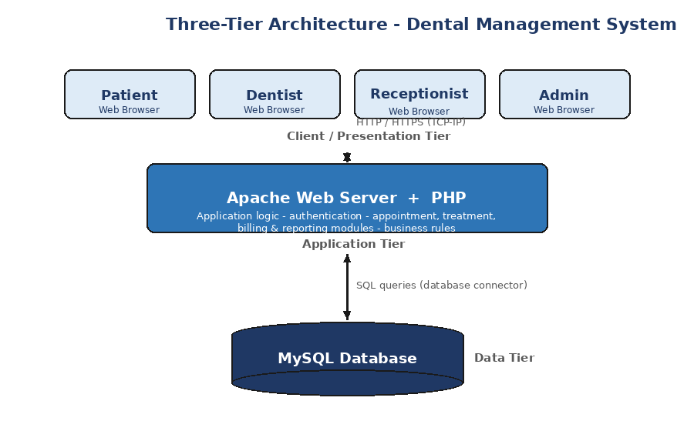
Figure 1.1: Three-Tier Architecture of the Dental Health management system

1.9 Gantt Chart

The project was planned and executed in clearly defined phases, from requirement gathering through to deployment. The following schedule summarizes the major tasks, their timeline and completion status.
Task No. | Task Name | Start Date | End Date | Duration | Progress (%)
1 | Requirement Gathering & Analysis | 2023-02-06 | 2023-02-20 | 14 days | 100%
2 | SRS Documentation | 2023-02-20 | 2023-03-03 | 10 days | 100%
3 | System Design (SDD, UML, ER) | 2023-03-06 | 2023-03-27 | 21 days | 100%
4 | Database Design & Setup | 2023-03-27 | 2023-04-07 | 10 days | 100%
5 | Front-End Development | 2023-04-10 | 2023-05-08 | 28 days | 100%
6 | Back-End Development (PHP) | 2023-05-08 | 2023-06-12 | 35 days | 100%
7 | Module Integration | 2023-06-12 | 2023-06-26 | 14 days | 100%
8 | Testing & Debugging | 2023-06-26 | 2023-07-14 | 18 days | 100%
9 | Deployment & Final Documentation | 2023-07-14 | 2023-07-28 | 12 days | 100%
Figure 1.2: Project Gantt Chart

1.10 Hardware and Software Specifications

Hardware Specifications
- Processor: Intel Core i5 or higher for smooth development and testing.
- RAM: Minimum 8 GB for running the local server and database.
- Storage: 256 GB SSD or higher for the codebase, database and tools.
- Network: Stable broadband internet connection.
- Display: Full HD monitor for clear interface design and testing.

Software Specifications
- Operating System: Windows 10/11, Ubuntu or macOS.
- Web Server: Apache 2.0 or higher (via XAMPP / WAMP).
- Server-Side Language: PHP 5.0 or higher (PHP 7+ recommended).
- Database: MySQL 5.0 or higher.
- Front-End: HTML5, CSS3, Bootstrap and JavaScript.
- Browsers: Google Chrome, Mozilla Firefox, Microsoft Edge (latest versions).
- Tools: Visual Studio Code, phpMyAdmin and Git.

1.11 Tools and Technologies Used with Reasoning

Front-End Technologies
HTML & CSS — used to structure and style the user interface, forming the visual foundation of every page.
Bootstrap — a responsive CSS framework that provides pre-designed components, allowing a consistent, mobile-friendly interface to be built quickly without writing extensive custom CSS.
JavaScript — adds client-side interactivity and performs form validation before data is sent to the server, improving the user experience.

Back-End Technologies
PHP — a widely supported server-side scripting language well-suited to web applications. It handles request processing, session management and all communication with the database.

Database Technologies
MySQL — a reliable, open-source relational database used to store structured and related dental records such as patients, appointments and transactions, with efficient querying and retrieval.

Server & Development Tools
Apache — serves the application and works seamlessly with PHP and MySQL as part of the standard LAMP / XAMPP stack.
phpMyAdmin — provides a convenient web interface for creating and managing the MySQL database.
Git — used for version control, enabling safe collaboration and tracking of changes over time.
Visual Studio Code — the primary development environment, offering helpful extensions for PHP and web development.

Chapter 2: Software Requirements Specification

2.1 Methodology

The methodology adopted for the Dental Health management system follows a structured, iterative software-development approach that moves through requirement gathering, analysis, design, implementation, testing and deployment. The aim was to build a reliable and maintainable system that accurately reflects the real workflows of a dental practice.

Requirement Gathering
The day-to-day workflows of a dental clinic were studied to identify the different user roles and their needs, including patient registration, appointment handling, treatment recording and billing.

Analysis
The collected requirements were analyzed and documented as functional and non-functional requirements, forming the Software Requirements Specification for the system.

Design
The system structure was modeled using use case, class, sequence, entity-relationship and architectural diagrams, which together formed the Software Design Description.

Implementation
The front end was developed using HTML, CSS, Bootstrap and JavaScript, while the back-end logic was implemented in PHP with a MySQL database for storage.

Testing & Deployment
Functional and non-functional testing was carried out across different browsers to verify correctness, performance and usability before the application was deployed on an Apache web server.

2.2 Functional Requirements

The functional requirements describe the specific behaviors and features the Dental Health management system must provide.
No. | Requirement | Description
FR1 | User Registration & Authentication | Users can register and securely log in. The system enforces role-based access for patients, dentists, receptionists, office managers and administrators, and supports password recovery and session management.
FR2 | Patient Management | The system creates, updates and maintains patient records including personal details, contact information, medical history and account status, with quick search and retrieval.
FR3 | Appointment Scheduling | Patients can book, reschedule or cancel appointments based on dentist availability. The system manages the schedule and can send appointment reminders.
FR4 | Treatment Management | Dentists can create and update treatment plans, record dental procedures and intra-oral examination results, and track treatment progress over time.
FR5 | Billing & Payment | The system generates invoices, records payments, manages transactions and tracks overdue accounts for completed services.
FR6 | Prescription Management | Dentists can record patient prescriptions, and authorized users can view prescription history.
FR7 | Reporting & Analytics | The system provides dashboards showing total patients, doctors, appointments and earnings, along with printable reports to support decision-making.
FR8 | Feedback Management | Patients can submit feedback about the service, and administrators can view and respond to it.
FR9 | Administration | Administrators can manage doctors, departments and staff, update profiles and send notifications to users.

2.3 Non-Functional Requirements

The non-functional requirements describe the quality attributes the system must satisfy.
No. | Attribute | Description
NFR1 | Reliability | The system must handle the large majority of user requests without failure, with proper error handling and recovery so that records are not lost during normal operation.
NFR2 | Security | Passwords must be stored securely and access must be controlled by user role. Patient information must be kept confidential and protected from unauthorized access in line with healthcare privacy expectations.
NFR3 | Performance | Pages and database operations should respond quickly, providing a responsive experience even when several users access the system at the same time.
NFR4 | Usability | The interface must be clean, intuitive and responsive, so that staff and patients with varying technical skill can use it with minimal training.
NFR5 | Portability | The system should operate across major operating systems and modern browsers, since it is delivered as a browser-based web application.
NFR6 | Scalability | The architecture should allow the number of users and records to grow, and be extendable to support additional clinics or branches in the future.
NFR7 | Maintainability | A modular design keeps the presentation, logic and data layers separate, making the system easier to update and extend.

2.4 Hardware Requirements

The following hardware is recommended to develop, host and run the Dental Health management system effectively.
Sr# | Component | Specification | Description
1 | Processor (CPU) | Intel Core i5 / AMD Ryzen 5 or higher | Supports the web server, database and development tools efficiently.
2 | RAM | Minimum 8 GB | Allows the local server, database and browser to run smoothly together.
3 | Storage | Minimum 256 GB SSD | Fast storage for the codebase, database and temporary files.
4 | Operating System | Windows 10/11, Ubuntu 20.04+ or macOS | Compatible with widely used systems for development and deployment.
5 | Display | Full HD (1920x1080) | Clear visualization of interfaces, forms and reports.
6 | Internet | Broadband, minimum 5–10 Mbps | Required for hosting, downloading dependencies and remote access.
Optional Server Hardware for Deployment
Sr# | Component | Specification | Description
1 | Application/DB Server | Quad-core CPU, 16 GB RAM, SSD storage | Hosts the Apache/PHP application and MySQL database for production use.
2 | Backup Storage | External or cloud storage | Regular backups of the patient database and uploaded records.

Chapter 3: Analysis

3.1 Use Case Diagrams

A use case diagram captures the interaction between the actors and the system, showing the functions each type of user can perform. In the Dental Health management system the main actors are the patient (user), the dental clinician (dentist), the receptionist, the office manager, the dental staff and the administrator, along with external healthcare systems for sharing records.

Patient / User Side
On the patient side, the user can enter the clinic and complete paperwork, undergo examination, answer medical-history questions, request a new appointment and take part in a medical consultation. The dental clinician collects the medical history, performs the examination and creates new appointments. Where a consultation requires further input, the case extends to a medical consult, and patient health information can be exchanged with an integrated electronic health-record system or with medical providers inside and outside the organization.
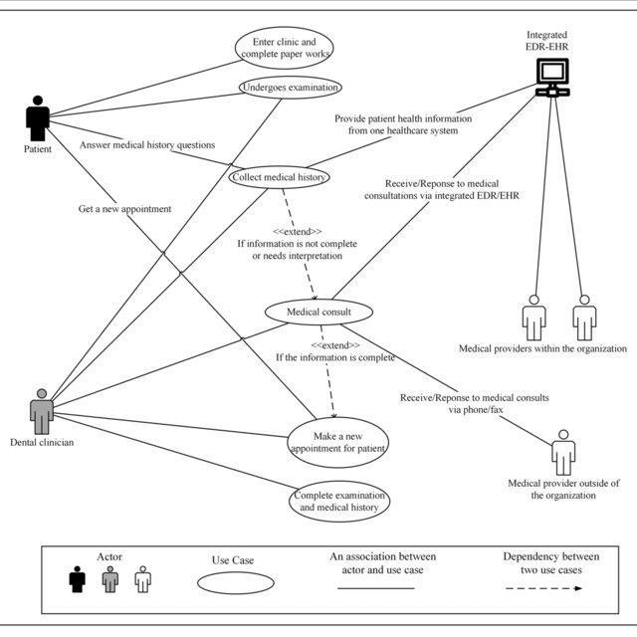
Figure 3.1: Use Case Diagram – Patient / User Side

Administrative Side
On the administrative side, the receptionist records office-visit information and maintains patient information. The office manager maintains dental-staff records, prints invoices, enters payments, views procedure information and prints overdue accounts. The dental staff records dental procedures and prints procedure reports. Together these use cases cover the front-desk, financial and clinical-record duties of the clinic.
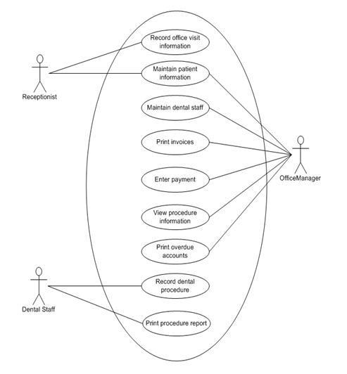
Figure 3.2: Use Case Diagram – Administrative Side

System Overview
At a high level, the administrator can add, edit and update categories, print patient results, encode records, view the reserved schedule and register or update information, while the user can view schedules and register or update their own details. This overview shows how administrative and user activities relate to the same shared system.
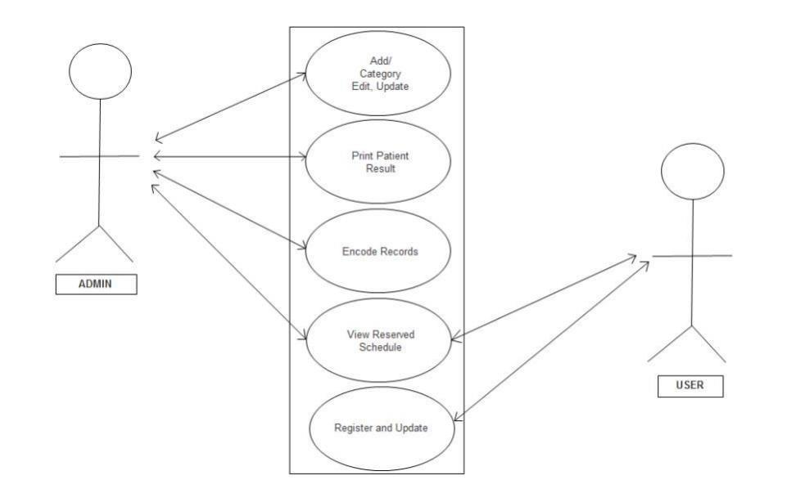
Figure 3.3: Use Case Diagram – System Overview (Admin / User)

3.2 Use Case Scenarios

The following scenarios describe the main interactions in detail, including the basic flow of events and the alternative and exceptional flows.

Table 3.1: User Registration
Use Case Name: User Registration
Participating Actors | Patient / User
Entry Condition | The user opens the registration form.
Basic Flow | 1. The user enters name, email, password, contact number, gender and address.  2. The system validates that all required fields are completed.  3. A database connection is created and the information is stored.  4. The system displays the message: “Successfully registered.”
Alternative Flow | A1: The user cancels registration; the form is closed without saving.
Exceptional Flow | E1: A required field is missing; the system displays: “Please fill all necessary fields.”
Exit Condition | The user account is created and stored in the database.

Table 3.2: User Login
Use Case Name: User Login
Participating Actors | Patient, Dentist, Receptionist, Office Manager, Administrator
Entry Condition | The user must already be registered and open the login page.
Basic Flow | 1. The user selects a role and enters email and password.  2. The system verifies the credentials against the MySQL database.  3. On success, the system displays “Login successful” and loads the dashboard for that role.
Alternative Flow | A1: The user selects “Forgot Password” and recovers the account by verifying the registered phone/email.
Exceptional Flow | E1: Incorrect credentials; the system displays: “Enter correct information.”
Exit Condition | The user gains access to the role-appropriate area of the system.

Table 3.3: Book Appointment
Use Case Name: Book Appointment
Participating Actors | Patient, Receptionist, Dentist
Entry Condition | The patient is logged in and requests an appointment.
Basic Flow | 1. The patient searches for an available dentist and time slot.  2. The system checks the dentist’s availability.  3. The patient selects a slot and confirms the appointment.  4. The system records the appointment and confirms the booking.
Alternative Flow | A1: The selected slot is taken; the system suggests the next available time.
Exceptional Flow | E1: No slots are available; the system notifies the patient to try another date.
Exit Condition | The appointment is scheduled and a reminder can be sent to the patient.

Table 3.4: Record Dental Procedure
Use Case Name: Record Dental Procedure
Participating Actors | Dentist / Dental Staff
Entry Condition | The patient is checked in and a treatment is being carried out.
Basic Flow | 1. The dentist opens the patient’s treatment record.  2. The procedure, intra-oral examination findings and notes are entered.  3. The system saves the record against the patient and updates treatment progress.  4. A procedure report can be printed if required.
Alternative Flow | A1: An existing treatment plan is updated instead of creating a new one.
Exceptional Flow | E1: A required field is incomplete; the system prompts the dentist to complete it before saving.
Exit Condition | The dental procedure is recorded in the patient’s history.

Table 3.5: Billing & Payment
Use Case Name: Billing & Payment
Participating Actors | Receptionist / Office Manager
Entry Condition | A treatment or service has been completed for the patient.
Basic Flow | 1. The system compiles the procedures and charges for the visit.  2. An invoice is generated for the patient.  3. The payment is recorded against the transaction.  4. The system updates the account and can print a receipt or overdue list.
Alternative Flow | A1: Partial payment is recorded and the balance is marked as outstanding.
Exceptional Flow | E1: A payment error occurs; the system alerts the user and the transaction is not saved.
Exit Condition | The invoice and payment are recorded and the account is updated.

Chapter 4: Design

4.1 Class Diagram

The class diagram represents the key classes of the Dental Health management system and the relationships between them. The core classes involved in scheduling are the Registry, Appointment, Dentist, Patient and the graphical user interface (GUI). The Registry provides operations to find available times and create appointments, the Dentist manages availability and schedules, and the Patient can search availability and book appointments.
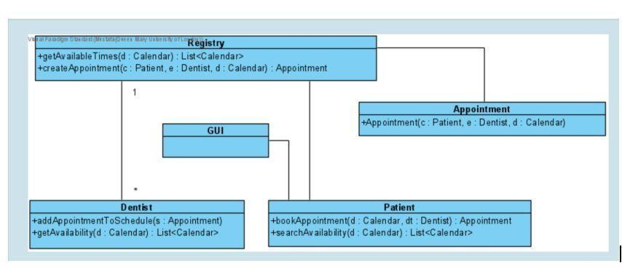
Figure 4.1: Class Diagram for the Dental Health management system
In addition to the scheduling classes shown above, the component design of the system defines several supporting classes that handle accounts, access and feedback. Their main responsibilities are summarized below.
Class | Responsibilities (Key Methods)
Registration | Creates, updates and deletes patient and user accounts and registers customers — createAccount(), updateAccount(), deleteAccount(), registerCustomer().
Login Credential | Handles authentication and session control — login(), forgetPassword(), resetPassword(), logout().
Patient / Customer | Represents the patient and their activities — login(), registration(), book/visit, registerComplaint(), logout().
Dentist | Manages dentist availability and schedules — addAppointmentToSchedule(), getAvailability().
Appointment | Represents a booking linking a patient, a dentist and a date/time.
Administrator | Manages the system — add/delete/update records, updateProfile(), sentEmail(), logout().
Feedback | Captures and responds to patient feedback — giveFeedback(), showFeedback(), response().

Relationships
- User and Image/Record: a user (patient) uploads records and information into the system.
- Patient and Appointment: a patient can book one or more appointments.
- Dentist and Appointment: a dentist is assigned appointments based on availability.
- Registry and Appointment: the registry creates and manages appointment objects.
- Administrator and Records: the administrator manages doctors, patients, departments and feedback.

4.2 Sequence Diagram

The sequence diagram shows the order of interactions for booking an appointment and completing a visit. The patient calls to schedule an appointment, the receptionist checks availability and records the appointment, and a confirmation is returned. At the visit, the patient checks in, their information is recorded and the dentist is notified. The dentist consults the patient and provides the dental service, after which the payment is made and recorded.
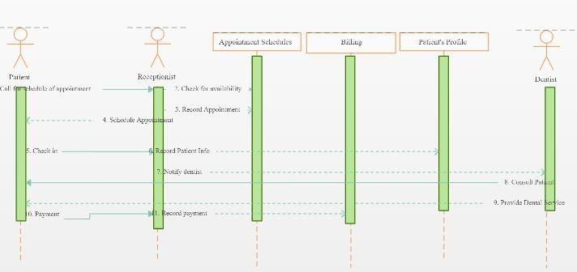
Figure 4.2: Sequence Diagram for Appointment and Treatment

Steps in the Sequence
- The patient calls or requests an appointment through the receptionist.
- The receptionist checks the appointment schedule for availability and records the appointment.
- A confirmation of the scheduled appointment is returned to the patient.
- At the visit, the patient checks in and their information is recorded in the patient profile.
- The dentist is notified and consults the patient, then provides the dental service.
- The payment is made and recorded against the billing module, completing the visit.

4.3 Entity-Relationship (ER) Diagram
The ER diagram models the main entities of the system and the relationships between them. The principal entities are User, Patient, Transaction and Intra-Oral Exam. A user records transactions, each transaction belongs to a patient and may reference an intra-oral examination, and each intra-oral exam is linked to a patient.
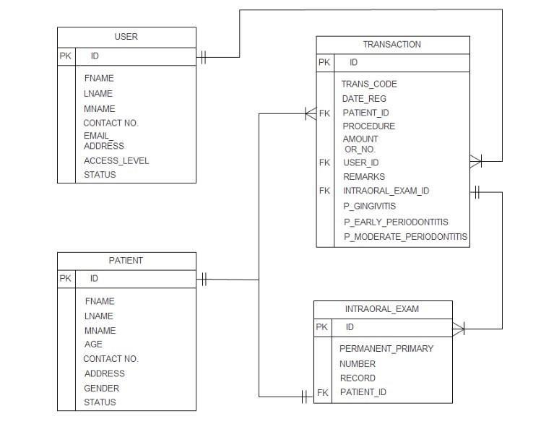
Figure 4.3: Entity-Relationship Diagram for the Dental Health management system

Entities and Attributes
- User: ID (PK), FName, LName, MName, Contact No, Email, Address, Access_Level, Status.
- Patient: ID (PK), FName, LName, MName, Age, Contact No, Address, Gender, Status.
- Transaction: ID (PK), Trans_Code, Date_Reg, Patient_ID (FK), Procedure, Amount, OR_No, User_ID (FK), Remarks, Intraoral_Exam_ID (FK).
- Intra-Oral Exam: ID (PK), Permanent_Primary, Number, Record, Patient_ID (FK).

4.4 Data Flow Diagram

The data flow diagram shows how information moves through the system. Patients and staff log in and pass through the registration process; data then flows through consultation, record update, payment and report-generation processes, interacting with the Patient, Transaction and official-receipt (OR) data stores along the way.
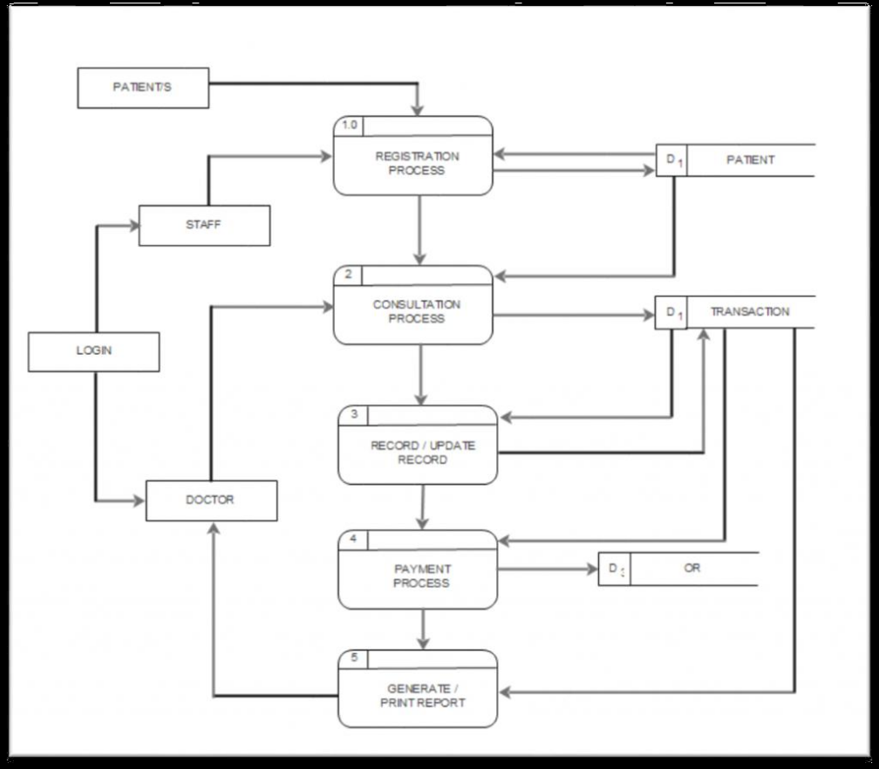
Figure 4.4: Data Flow Diagram for the Dental Health management system

4.5 Database Schema

The database schema defines the tables used to store the system’s data. The main tables and their fields are listed below.

User Table
Field | Type | Key / Description
ID | INT | Primary key – unique user identifier.
FName / LName / MName | VARCHAR | User’s first, last and middle name.
Contact_No | VARCHAR | Contact number.
Email | VARCHAR | User email address.
Address | VARCHAR | User address.
Access_Level | VARCHAR | Role (admin, dentist, receptionist, etc.).
Status | ENUM | Active / inactive status.

Patient Table
Field | Type | Key / Description
ID | INT | Primary key – unique patient identifier.
FName / LName / MName | VARCHAR | Patient’s names.
Age | INT | Patient age.
Contact_No | VARCHAR | Contact number.
Address | VARCHAR | Patient address.
Gender | CHAR | Patient gender.
Status | ENUM | Patient status.

Transaction Table
Field | Type | Key / Description
ID | INT | Primary key – transaction identifier.
Trans_Code | VARCHAR | Transaction code.
Date_Reg | DATETIME | Date of the transaction.
Patient_ID | INT | Foreign key → Patient.
User_ID | INT | Foreign key → User.
Procedure | VARCHAR | Procedure performed.
Amount | DECIMAL | Amount charged.
Intraoral_Exam_ID | INT | Foreign key → Intra-Oral Exam.

Intra-Oral Exam Table
Field | Type | Key / Description
ID | INT | Primary key – exam identifier.
Permanent_Primary | VARCHAR | Tooth type indicator.
Number | INT | Tooth number / count.
Record | TEXT | Examination notes.
Patient_ID | INT | Foreign key → Patient.

4.6 Architectural Diagram

The architectural diagram presents the system as a set of cooperating layers. Each layer has a clear responsibility and communicates only with the layers directly adjacent to it, which keeps the design clean and maintainable.
- Presentation Layer (UI): the web interface built with HTML, CSS, Bootstrap and JavaScript, where patients and staff upload information and view reports.
- Application Layer: PHP handles application logic, request processing and session management for the appointment, treatment and billing modules.
- Data Access Layer: the database connector validates input and performs create, read, update and delete operations.
- Data Layer: the MySQL database stores all patient, user, appointment, transaction and feedback records.
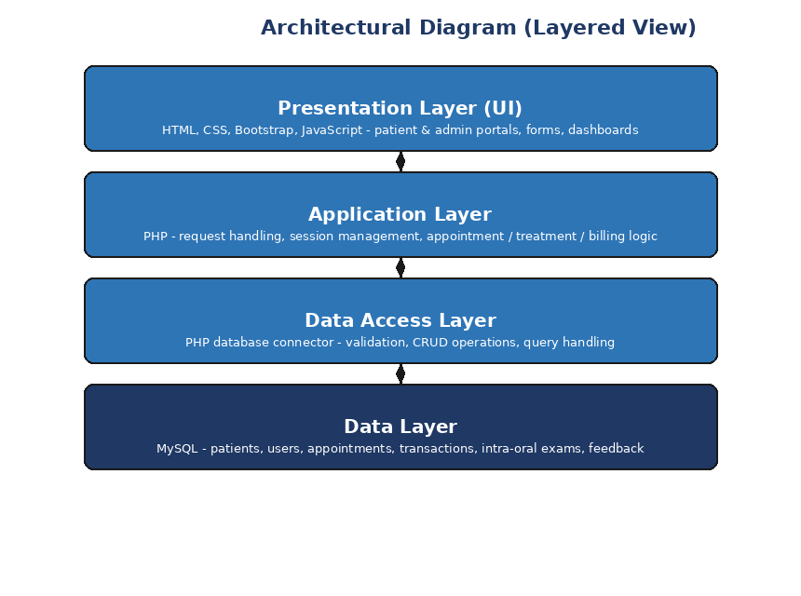
Figure 4.5: Architectural Diagram (Layered View)

Chapter 5: Graphical User Interface

5.1 Graphical User Interface

The graphical user interface of the Dental Health management system is designed to be clean, consistent and easy to navigate for both patients and clinic staff. A shared sidebar gives access to the main modules — dashboard, appointments, prescriptions, doctors, patients and treatment records — while each screen presents its information in clearly labelled tables and forms. The following screens illustrate the main parts of the system.

Login Page
The login page allows registered users to access the system. The user selects their role, enters a valid email and password, and is taken to the appropriate dashboard. A “Forgot Password?” link is provided for account recovery.
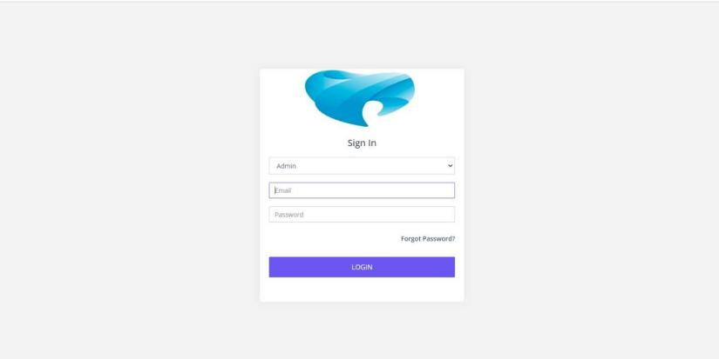
Figure 5.1: Login Page

Administrator Dashboard
The dashboard gives the administrator an overview of the clinic at a glance, showing total patients, total doctors, active admins and earnings, along with charts of appointments and patients over the year.
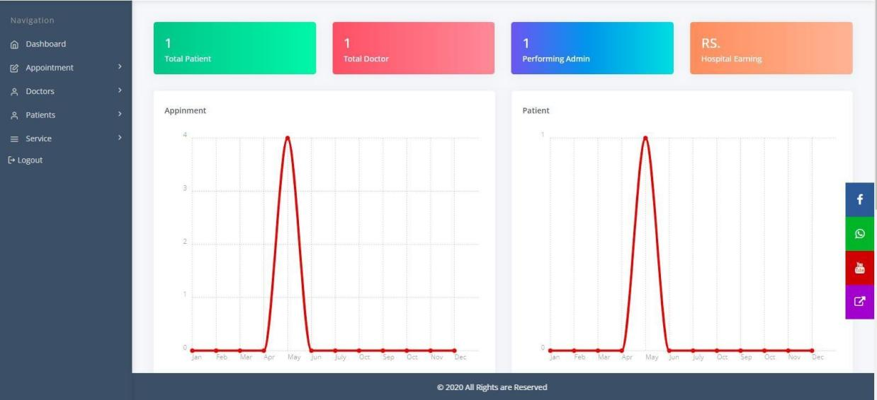
Figure 5.2: Administrator Dashboard

Doctors Management
This screen lists all doctors available in the clinic along with their department, contact number, login ID, consultancy charge, qualification, experience and status. Administrators can add, edit or remove doctor records.
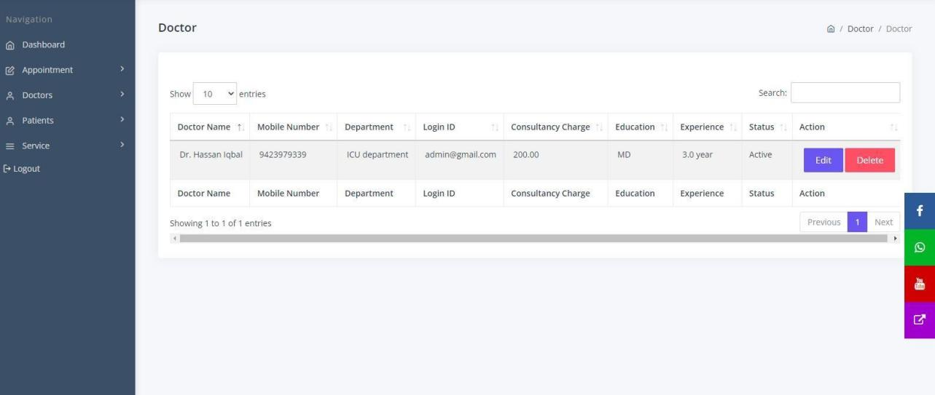
Figure 5.3: Doctors Management

Patient List
The patient screen displays all registered patients with their admission details, address and patient profile, including blood group, gender and date of birth. Staff can edit a record, view a report or update the patient’s status.
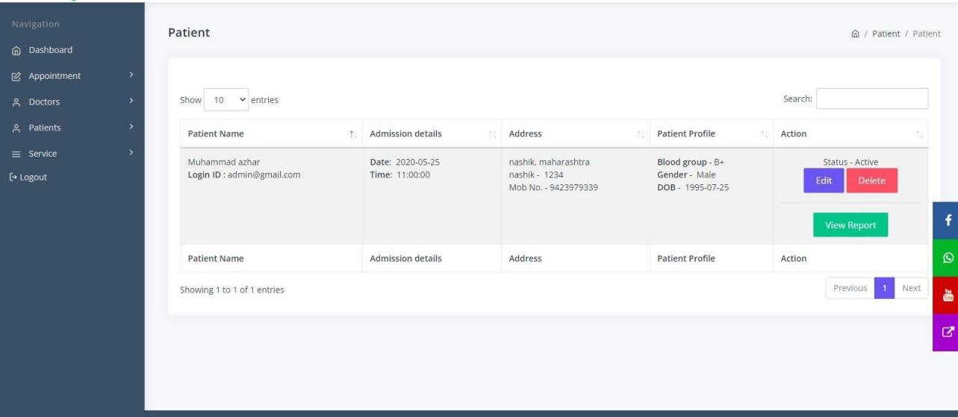
Figure 5.4: Patient List

Treatment Record
The treatment-record screen shows the history of treatments for patients, including treatment type, the patient and doctor involved, a description and the treatment date and time. Records can be searched and filtered.
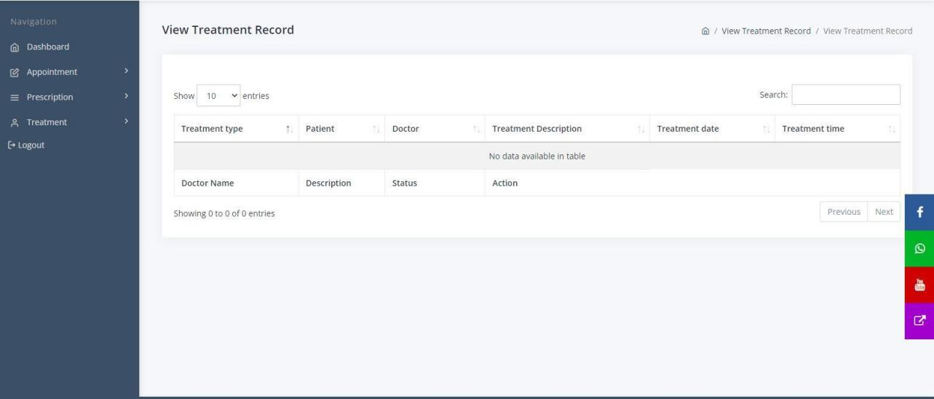
Figure 5.5: Treatment Record

Department Management
This screen allows administrators to add, update and delete the departments offered by the clinic, each with a description and status.
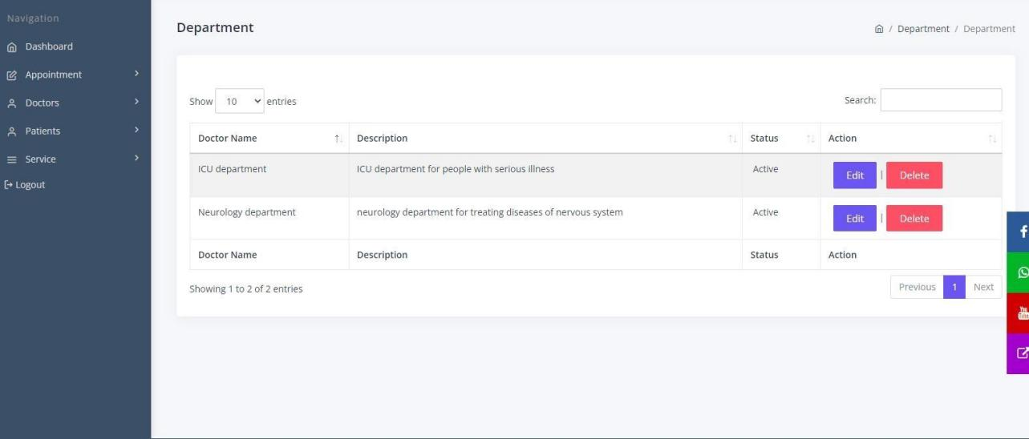
Figure 5.6: Department Management

Password Recovery
If a user forgets their password, the recovery screen lets them enter their registered email address and reset their password securely, before returning to the login page.
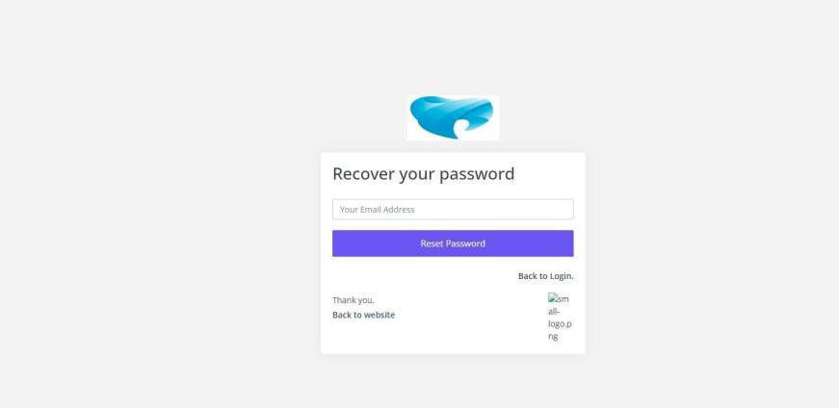
Figure 5.7: Password Recovery

Chapter 6: Testing

6.1 Introduction

Testing is a critical stage that ensures the Dental Health management system’s front end, back-end logic and database all work together correctly. Testing focused on the core features of the system — user authentication, patient and appointment management, treatment recording, billing and reporting — as well as behavior across different browsers. The goal was to verify the reliability, performance and usability of the system for the patients and staff who depend on it.

6.2 Test Scenarios

Test Case ID: 01 — User Login
Priority: High. Preconditions: the user must be registered.
SN | Action | Input | Expected Result | Actual Result | Status
1 | Launch the application | Open in browser | Login page loads with role, email and password fields | Login page displayed | PASS
2 | Enter valid credentials | Correct email & password | User is logged in and dashboard loads | Dashboard loaded successfully | PASS
3 | Enter invalid credentials | Wrong password | Error message is shown | “Enter correct information” displayed | PASS

Test Case ID: 02 — Appointment Booking
Priority: High. Preconditions: the patient is logged in.
SN | Action | Input | Expected Result | Actual Result | Status
1 | Search availability | Select dentist & date | Available time slots are shown | Slots displayed correctly | PASS
2 | Book an open slot | Select slot & confirm | Appointment is recorded and confirmed | Appointment booked successfully | PASS
3 | Book a taken slot | Select unavailable slot | System suggests another time | Next available slot suggested | PASS

Test Case ID: 03 — Billing & Payment
Priority: Medium. Preconditions: a treatment has been completed.
SN | Action | Input | Expected Result | Actual Result | Status
1 | Generate invoice | Completed procedures | Invoice with charges is created | Invoice generated correctly | PASS
2 | Record payment | Payment amount | Payment is saved and account updated | Payment recorded successfully | PASS
3 | View report | Open reports | Report shows patient and earning data | Report displayed clearly | PASS

Test Case ID: 04 — Patient Registration
Priority: High. Preconditions: the registration form is open.
SN | Action | Input | Expected Result | Actual Result | Status
1 | Submit complete form | All required fields | Account is created and stored | “Successfully registered” shown | PASS
2 | Submit incomplete form | Missing field | Validation message is shown | “Fill all necessary fields” shown | PASS

6.3 Test Plan Summary

Test Policy
Testing covers the entire system, including user authentication, patient and appointment management, treatment recording, billing, reporting and overall interface behavior.

Objectives
- Ensure accurate handling of patient, appointment and treatment data.
- Confirm quick and responsive page and database operations.
- Validate the correctness of invoices, payments and reports.
- Ensure secure authentication and protection of patient data.

Test Strategy
- Functional testing of each module.
- Compatibility testing across browsers.
- Usability testing of the interface.
- Performance and security testing.

Test Environment
- Devices: desktop and laptop browsers.
- Operating Systems: Windows 10/11 and Ubuntu.
- Browsers: Google Chrome and Mozilla Firefox.
- Tools: phpMyAdmin (database) and the local Apache server.

Test Schedule
- Week 1: Authentication and patient/registration testing.
- Week 2: Appointment and treatment-record testing.
- Week 3: Billing, reporting and integration testing.

Risks & Contingencies
- Database errors → input validation and error handling.
- Browser compatibility → cross-browser testing.
- Invalid data entry → form validation on the client and server.

Chapter 7: Future Work & Conclusion

7.1 Future Work

The current version of the Dental Health management system provides a solid foundation covering the essential operations of a dental clinic. Several enhancements are planned to extend its capabilities further:
- Mobile Application: native Android and iOS apps to give patients and staff convenient access on the go.
- Telehealth Integration: live video consultations for remote patient advice.
- Automated Insurance Claims: direct integration with insurance payers for electronic claim submission.
- Smart Scheduling & Analytics: predictive features to reduce no-shows and forecast clinic demand.
- Multi-Clinic / Cloud Deployment: scaling the system to support multiple branches under a single cloud-hosted platform.
- Patient Notifications: automated SMS and push reminders for appointments and follow-ups.

7.2 Conclusion

The Dental Health management system successfully digitizes the core operations of a dental practice — patient records, appointment scheduling, treatment and prescription management, billing and reporting — within a secure, role-based web platform built using PHP and MySQL. By replacing manual, paper-based processes with a centralized system, it reduces administrative effort, improves the accuracy and availability of records, and enhances the overall patient experience.
The project was developed through a structured process of requirement analysis, design, implementation and testing, and the testing results confirmed that the system reliably handles its key workflows across modern browsers. With the planned future enhancements — particularly mobile access, telehealth and cloud scalability — the platform has strong potential to serve a wide range of dental clinics and to grow alongside their needs.

Chapter A
Glossary

  - DHMS: Dental Health Management System

  - EHR: Electronic Health Record (digitized clinical history of patients)

  - 3NF: Third Normal Form (database design structure to prevent data redundancy)

  - FK: Foreign Key (relational database reference pointer)

  - HIPAA: Health Insurance Portability and Accountability Act (medical privacy guidelines)
  - RBAC: Role-Based Access Control (session access restrictions based on user roles)

Chapter B
Deployment/Installation Guide

Follow these steps to deploy and run the system locally:

- Install XAMPP Server (which includes Apache and MySQL).

- Download the project code folder and place it in the XAMPP directory:
C:\xampp\htdocs\dhms.

- Start Apache and MySQL from the XAMPP Control Panel.

- Open your web browser and go to http://localhost/phpmyadmin.

- Create a new database named dhms_db and import the SQL file: C:\xampp\htdocs\dhms\database\d

- Configure database connection parameters in C:\xampp\htdocs\dhms\config.php.

- Open browser and access the application at http://localhost/dhms.

